FACULTY EVALUATION
Programme Name: SEP Scale Alumni Masterclass Module 1 Tanzania (11th May 2026 - 15th May 2026)
Session: Reflection and leadership and teams (employees)
Faculty Name: Dr. Joan Wanjiku Ndung'u - Gitahi
No. of Respondents: 14
No. of Participants: 14
Evaluation Parameter | (%) Individual Score | (%) Programme Average
Punctuality (Commencement and Completion of Sessions) | 97 | 92
How well do you understand the core concepts presented? | 93 | 88
Rate your confidence in applying the new skills learnt | 84 | 85
Degree of Faculty preparedness for the sessions | 91 | 90
Content and methodology of the program | 90 | 90
Quality of class and group discussions | 91 | 89
The information presented in the course is relevant to my work (ministry) | 93 | 92
Average scores | 91 | 89

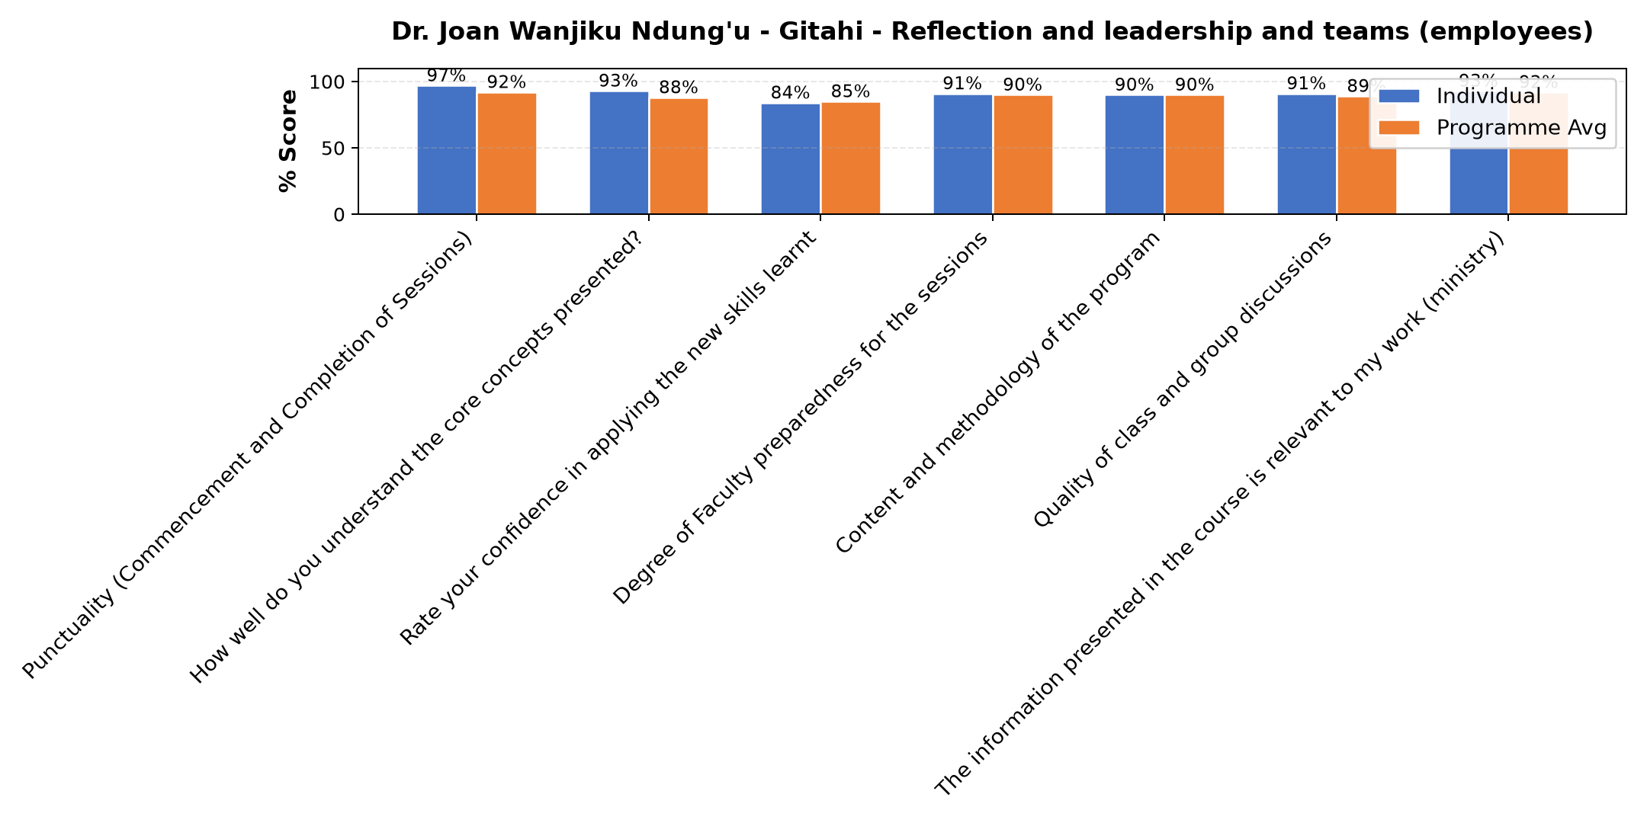

Comments & Feedback
- • Is just my behavior
- • Some barriers that might prevent me from applying what I learned include my tendency to stick to one communication style instead of adapting to different personalities. Also, work pressure or lack of time may make me forget to apply the appropriate communication approach. In addition, lack of enough practice may make it difficult for me to adjust quickly in real situations.
- • The questions asking only one person at whole period
- • By knowing my self and to know one another and to appreciate what others do
- • No
- • The challenge would be balancing the colours and be able to cope with others.
- • Different personalities but I will try to aply the knowledge I learnt today
- • Nothing
- • The possible barrier is trying to make other people behave as I wish, based on the dominant colour. There might be disappointments when things go differently.
- • May be In connection with my workers otherwise there is no barrier
- • Kushindwa kusimama katika nafasi yangu mimi mwenyewe
SUBMITTED THROUGH:
SBS Evaluation Automation System

